***2.2 Functional Requirements Specification***

This section outlines the use cases for each of the active readers separately. The reader, the author and the reviewer have only one use case apiece while the editor is main actor in this system.

### 2.2.1 Developer Use Cases

#### The Developer has the following set of use cases:

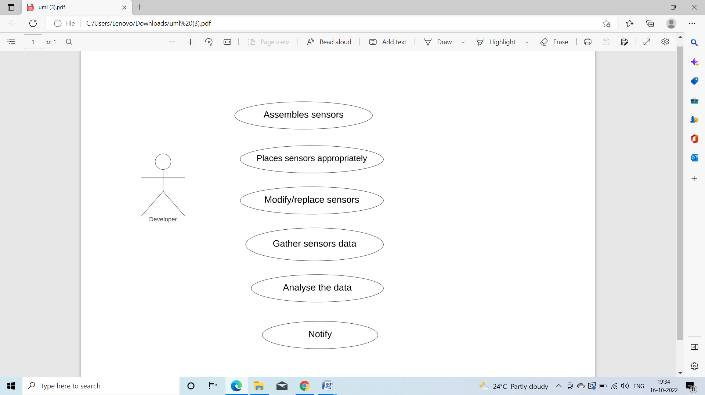

Use case: Assembles sensors

**Diagram:**

Developer

Assembles sensors

**Brief Description**

The developer gathers all the necessary sensors.

**Initial Step-By-Step Description**

1. The developer collects all the sensors.
2. Then eliminates the sensors which are not necessary.

Use case: Places sensors appropriately

**Diagram:**

Developer

Places sensors appropriatelyy

**Brief Description**

Based on the working of sensors, developer places sensors properly.

**Initial Step-By-Step Description**

1. The developer identifies working of each sensor.
2. Then places sensors properly.
3. If any sensor is kept at wrong place then he/she adjusts its position

Use case: Replaces sensors

**Diagram:**

Developer

Replaces sensors

**Brief Description**

The developer replaces the inefficient sensors with the efficient ones.

**Initial Step-By-Step Description**.

1. The developer will see the working of each sensor.
2. He/she searches for more efficient sensor than the present ones considering all factors.
3. Finally developer replaces the current sensor with more efficient one for accurate output.

Use case: Gathers sensors data

**Diagram:**

Developer

Gathers sensors data

**Brief Description:**

Developer gathers all the data from various sensors that were placed.

**Initial Step-By-Step Description**

1. At first, the developer notes down the values properly from all the sensors that were placed.
2. He/she once again cross checks whether data is collected from all the sensors or not.

Use case: Analyse the data

**Diagram:**

Developer

Analyse the data

**Brief Description**

The Developer analyses the data that is collected from various sensors.

**Initial Step-By-Step Description**

1. The developer will look at all the data that is collected from various sensors.
2. He/she properly interprets the data that is collected.

Use case: Notify

**Diagram:**

Developer

Notify

**Brief Description**

The developer will notify the nearest corporate office if the data collected exceeds the threshold.

**Initial Step-By-Step Description**

1. The developer checks whether the collected data exceeds the threshold value or not.
2. If the data collected exceeds the threshold value then the nearest corporate office will be notified.